**COURSEWORK SUBMISSION FORM**

|  |  |  |  |
| --- | --- | --- | --- |
| **STUDENT USE** | | **STAFF USE** | |
| Module Name | Information Systems Management | First Marker’s  (acts as signature) |  |
| Module Code | **5BUIS011C-n** | Second Marker’s  (acts as signature) |  |
| Lecturer Name | Daryoush Alimohammadi | Agreed Mark |  |
| UoW Student IDs |  | **For Registrar’s office use only (hard copy submission)** | |
| WIUT Student IDs | 00010023 |
| Deadline Date | 14/04/2022 11:59:59 PM |
| Assignment Type | ☐ Group ☑ Individual |
| Word Count | 2240 |

**SUBMISSION INSTRUCTIONS**

**COURSEWORKS *must* be submitted in *both* HARD COPY (to the Registrar’s Office) *and* ELECTRONIC unless instructed otherwise.**

For hardcopy submission instructions refer to: <http://intranet.wiut.uz/Shared%20Documents/Forms/AllItems.aspx> - Coursework hard copy submission instructions.doc

For online submission instructions refer to: <http://intranet.wiut.uz/Shared%20Documents/Forms/AllItems.aspx> - Coursework online submission instructions.doc

|  |
| --- |
| **MARKERS FEEDBACK (Continued on the next page)** |
|  |

Table of Contents

Company overview 2

Process management 3

Production volume. 4

Manufacturing Policy 4

How they manage hierarchical levels and time span in the planning 5

What is their policy to choose between finite and infinite loading? 5

How they assign operating priorities (Cost/Time/Flexibility/Quality)? 6

How they follow IT operations managements steps? 7

Summary 8

Reference list 9

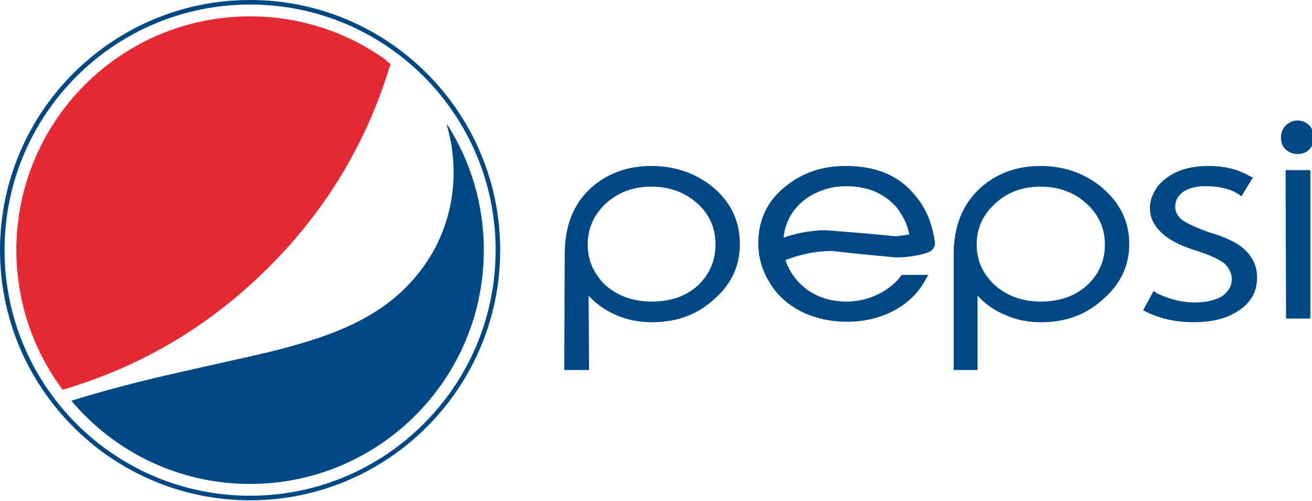

# Company overview

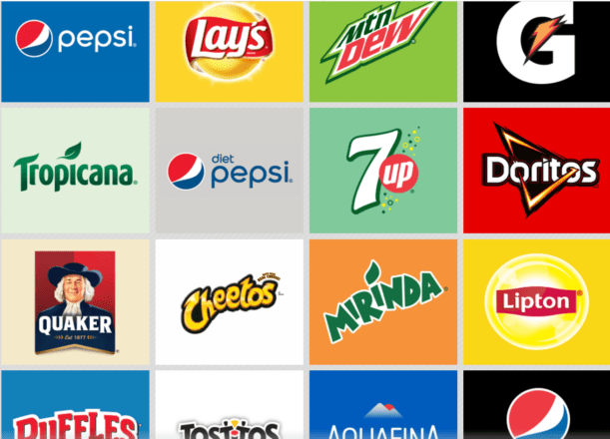PepsiCo – global well-recognisable brand with a long history. It operates in more than 200 countries around the world, with many branches and subsidiaries. In 2020, the net revenue generated by the company constituted more than $70 billion. Its products are enjoyed by customers more than one billion times a day and include, but not limited to Lays, Cheetos, Pepsi-Cola, Mountain Dew, Mirinda, and others. In Uzbekistan, a branch was opened in the middle of 2011. The first product produced was Pepsi Cola beverage. Initially, the people did not embrace the brand with much interest and trust. They thought that Pepsi Cola was one of local Uzbek beverages that mainly copied the Coca Cola. Soon after many advertisements and marketing efforts, people started to recognize a global brand in the company. Its products started to fill the shelves of many stores, including the giant Uzbek retail stores, such as korzinka.uz and macro. Given the rise in the demand, the factory started to expand and diversify the product line. The branch now produces consumer conveniences, such as Lays, Mountain Dew, Pepsi Cola, Mirinda, 7Up, and some energetic beverages (*Figure* ***1***). Despite being produced in outskirts of Tashkent city, the products of the company are distributed to all regions of Uzbekistan, to be found even in the furthest corners of the country. Also, producing millions of products annually, the company is relatively small, and the number of employees barely reaches 50 people. The following report will analyze the company in terms of its operation management and provide recommendations on how the company can improve the existing situation.

**Figure 1. Product line**

# Process management

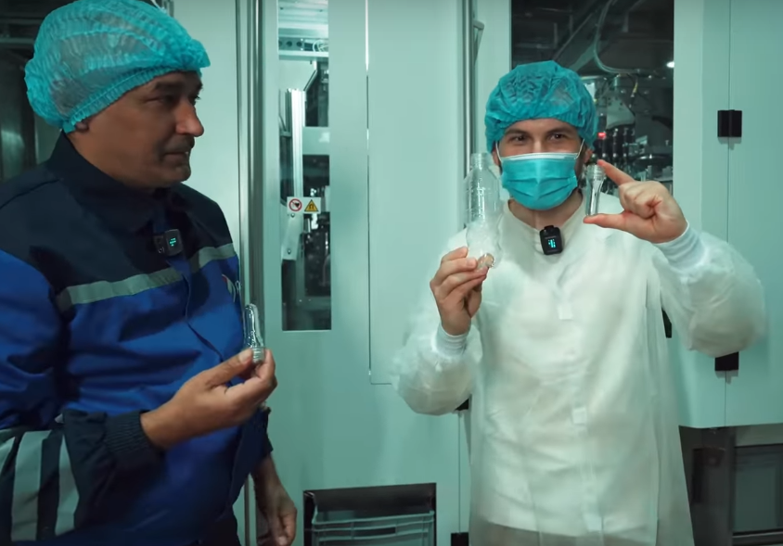The production process is wholly automated. The factory has many production lines, which produce a certain type of product only. However, the main profit maker and the best-selling product for the company is Pepsi Cola beverage. The beverage is produced in one production line which is supervised by 4 employees. The initial step of making pepsi beverage is filtering the water. The water passes through super tiny filters that are 5 microns wide. The helps to ensure that water is clear from different particles. Afterwards, the filtered water is sterilized through ultra-violet rays that kill all bacteria and malicious microorganisms. All this is performed by the computer system, without the intervention of human. At the same time, at the other part of the factory bottles are being created. They are made using small “preforms” as illustrated in Figure 3. These are heated and given a shape of a bottle. The bottles are then cooled down to 10 degrees of Celsius to be compatible with the beverage. Again, the whole process is fully automated, except for preforms uploading stage which is done by a person. The ready bottles are transferred to the stage where they are filled in with the cola beverage. The beverage is made by adding to the clean and filtered water special powder, sugar, and other relevant chemicals. The ready bottles are tightly capped and marked, before being sent to the packaging machine. The machine puts the small boxes of Pepsi colas into a huge one block and packages it with polyethylene film. The ready boxes are carried to the warehouse and stored until being sold.

# Production volume.

Balancing the production volume is essential for each manufacturing company. If more is produced and not sold within a certain time span, there is a risk of wasting the inventory. However, this is the not the case for the Pepsi Company. According to Qahramon Islomov, Director of marketing department, the demand for pepsi beverage is quite huge. His words are supported by Dilmurod Muxtarov, the manufacturing director, who says that company is planning to expand its capacity by installing new production line to meet the demand. In other words, sales demand is not the number one constraint for the company, but the capacity is. The volume of production is only limited to the number of units it can physically produce within a given time frame. For that reason, company tries to produce the beverage on a non-stop basis to fill that market gap. Pepsi is trying and seeking for ways to improve its production volume without worsening the quality of the product. After analyzing the situation, the following recommendation is made from my side. Pepsi company management may use so called “throughput accounting”, which is part of the theory of constrains. Throughput accounting tries to increase throughput of the machine, which is the reason of a bottleneck. After identifying the machine which causes some delays in the process, this machine can either be replaced with a machine with better capacity or the existing machine can be ameliorated. However, it should be noted that eliminating one bottleneck might create another one. This can be a difficult and time-consuming process, but its advantages might the increased production volume, time saved and reduction of wastage.

# Manufacturing Policy

Different companies utilize different manufacturing polices, based on their industry and business. Two most common polices are manufacturing to order and manufacturing under continuous process. The former is most relevant for companies that produce unique items. For example, Boing, one of the aircraft manufacturers, uses the manufacturing to order policy. It designs its airplanes and adds certain details to it based on customer preferences. As a result, all airplanes produced by the company have different specifications and are unique in nature. The other policy is mostly used by companies that produce similar in nature products. Pepsi is one example of it. Products of the company are produced in bulk for general consumption. Hence, company’s policy can be described as manufacturing under continuous process. Each bottle of Pepsi is made using the same ingredient and undergoes the same process. It cannot be adapted to individual customer preferences and cannot be produced to satisfy the needs of a certain client.

# How they manage hierarchical levels and time span in the planning

Pepsi Uzbekistan is a small company as mentioned above. The number of employees does not even exceed 50 people. Hence, it does not have a certain hierarchy. Basically, each employee can directly discuss the issue with the director. For that reason, there is nothing to say about the hierarchy. The decision-making process is also fast, as it does not take long to convey the decision to relevant employees. It can be done using the social media, such as Telegram. Overall, after reviewing the web sources and watching the interviews, it can be concluded that wide hierarchy has definite advantages to the company. For example, Nodira Tursunxo’jaeva, who is responsible for cleaning of the factory, says that she is pleasant with the working conditions and management. She mentions that management have excellent relations with employees. The Manufacturing Director, Sales department Director, and the General Director respect the employees and create all necessary conditions for performing the job. She is pleasant with her job and work conditions that exist there.

# What is their policy to choose between finite and infinite loading?

“Finite loading occurs when only a set amount of work is allocated to a work centre, which is capped at its estimated capacity level.”(AccountingTools, 2021). The finite loading is a time-consuming process which includes identifying the capacity levels of different machines, processes, and jobs. After the limits are found, they are now included in the production schedule to calculate the maximum amount that can be produced given the current constrains. With the finite loading, more precise resource allocation can be achieved. On the other hand, infinite capacity scheduling or infinite loading will assume that there is sufficient capacity available, and it is possible to schedule many orders in the same time frame. (Planet together, 2021). This type of loading is the most prevalent one and used in practice by many companies. It is relatively easy to construct and manage. However, regarding the Pepsi company, which is already working at full capacity, it is an inappropriate system. Pepsi is following finite loading. The management has been trying to eliminate the barriers that deter factory from producing more. This is a time-consuming process which involves a detailed study of all stages in production. However, with the years of practice, the results are quite impressive. The current factory operates with minimum human intervention, as most of the job is done by the robots. This helped the company to eliminate the human factor in certain stages of production. As a result, now the production process is more efficient, and wastage is minimized.

# How they assign operating priorities (Cost/Time/Flexibility/Quality)?

Certainly, companies need to balance between many objectives to provide a good quality product. However, it is a difficult task to balance between these objectives to provide the best experience to the customer. Every industry and business have their own customer preferences. For example, Apple products are well-known for their quality and brand. Customers are willing to pay high prices for the products of the company, which helps Apple to charge high prices, which are above their competitors. Meanwhile, users of Lenovo laptops appreciate the company’s efforts for providing low-cost, good quality laptops. Lenovo customers might be price-sensitive, as they are used to receive good services at a relatively lower price. Regarding the Pepsi Uzbekistan, the company prioritizes quality over other factors. As a global brand, the quality is what matters the most to the company. This is emphasized by the manufacturing director, Dilmurod Muxtarov, who says that quality is what makes Pepsi cola the global brand. The second most important factor is cost. Given the competition that exists in the market, Pepsi cannot charge price that is higher than its competitors. Therefore, company tries to keep costs as low as possible and maintain good quality of its beverages. It seeks for ways to minimize the costs, without affecting the quality. Pepsi has regular quality control checks every A picture containing text, person, indoor, ceiling
30 minutes. The laboratory, which is located inside the factory, takes samples of the beverage and tests it to see whether the product meets the requirements. Umida Joniqulova is a person responsible for that. Her department controls the quality of each production lines by making relevant tests to ensure that products meet the PepsiCo standards. According to her, quality controls by the head office are done at any time. The relevant representative of PepsiCo visit Uzbekistan and purchase company’s products from local stores. Then, these samples are sent to the main laboratory located in the head office. This quality test by PepsiCo is the best way to identify branches that violate PepsiCo international standards. Regarding the other priorities, such as time and flexibility, Pepsi does have certain issues. The analysis found that Pepsi Uzbekistan is not efficient in timing of delivery. The only method that they sue to distribute their products is thorough the lorries. However, although this is the cheapest way of delivery, it takes time to carry the products to the other regions. The average lead time, as mentioned by one of the directors, is around 2-3 days. In other words, it takes from to 2 to 3 days on average to deliver Pepsi beverages from the factory to the customer who is in another region of Uzbekistan. This might damage the reputation and lead to customer dissatisfaction. Customers, who acquire Pepsi products, might lose sales revenue which might amount to a significant value for their business within these two days. The recommendation would be to use other means of transportation. For example, railway offers a faster delivery at a moderate price. Pepsi might arrange a delivery option which would involve delivery of Pepsi products through the trains to other regions of Uzbekistan. From the railway station then, the products can be distributed quickly to the customers.

# How they follow IT operations managements steps?

Even though Pepsi Uzbekistan is a company with small number of employees, it heavily depends on sound IT system. Its production line, sales and distribution departments use the IT system to perform their tasks. For that reason, they have a separate IT department responsible for the maintenance of internal systems. If analysing the company in terms of three key service areas, the following can be mentioned.

*Network infrastructure management*. Networking infrastructure deals with providing external and internal communications to the business. The managers will maintain all the necessary equipment for performing of the task. In this regard, IT department in Pepsi manages the internal telephone system and maintains network security.

*Server and device management.* The administration of network endpoints, such as different devices and servers, is a task for which the IT Operations team is responsible for. In Pepsi, the IT department administers the conditions of servers to ensure that they function well. At the same time, the department controls the storage usage of different systems. If the server become fully employed, then the department puts orders to acquire additional devices for wit more space.

*Computer operations and Help Desk.* IT operations management comprises the management of help desk services such. The management is also responsible for scheduling and managing data backups. The procedure is done frequently to ensure that all data is saved and can be restore in case of disasters.

# Summary

The report discussed the operations of Pepsi Uzbekistan company. Analysis revealed that Pepsi has a good and sound IT system. The production was found to be fully automated, with capacity being the only constraint to expansion. The roles of IT department were identified, as well as the types of manufacturing polices and assigning priorities.

# Reference list

Business Class (2022). Pepsi qanday ishlab chiqariladi? — Hech kimga ko‘rsatilmagan zavod. *YouTube.* Available from <https://www.youtube.com/watch?v=Js9ziiY8-ME> [Accessed 10 April 2022].

Accounting tools (2021). Finite loading definition. *AccountingTools*. Available from <https://www.accountingtools.com/articles/finite-loading-definition> [Accessed 11 April 2022].

Planet Together (2021). The Difference Between Finite Capacity Scheduling and Infinite Capacity Loading. *Planet Together.* Available from <https://www.planettogether.com/blog/the-difference-between-finite-capacity-scheduling-and-infinite-capacity-loading> [Accessed 11 April 2022].

